Once you have added a deal click Edit and the proposal forms now appear in the list:

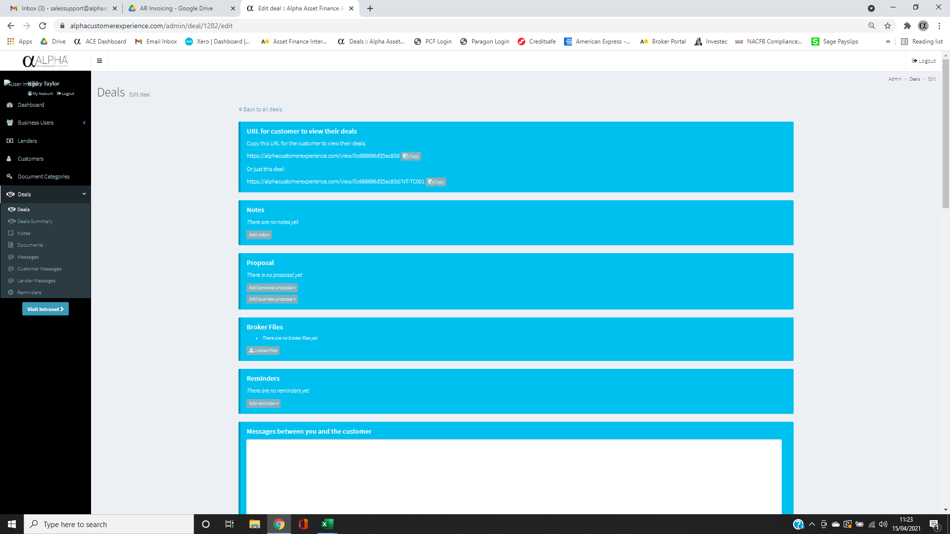



Click either the personal or business depending whether the deal is regulated or unregulated and the process is slightly different. The person proposal allows you to send the prop over to your customer to edit and return before you covert to a pdf whereas the business one is only editable by you.

Business: go through the tabs at the top completing the information and click Save and back to save the form (don’t forget to save as it will wipe the form if ACE times out etc)

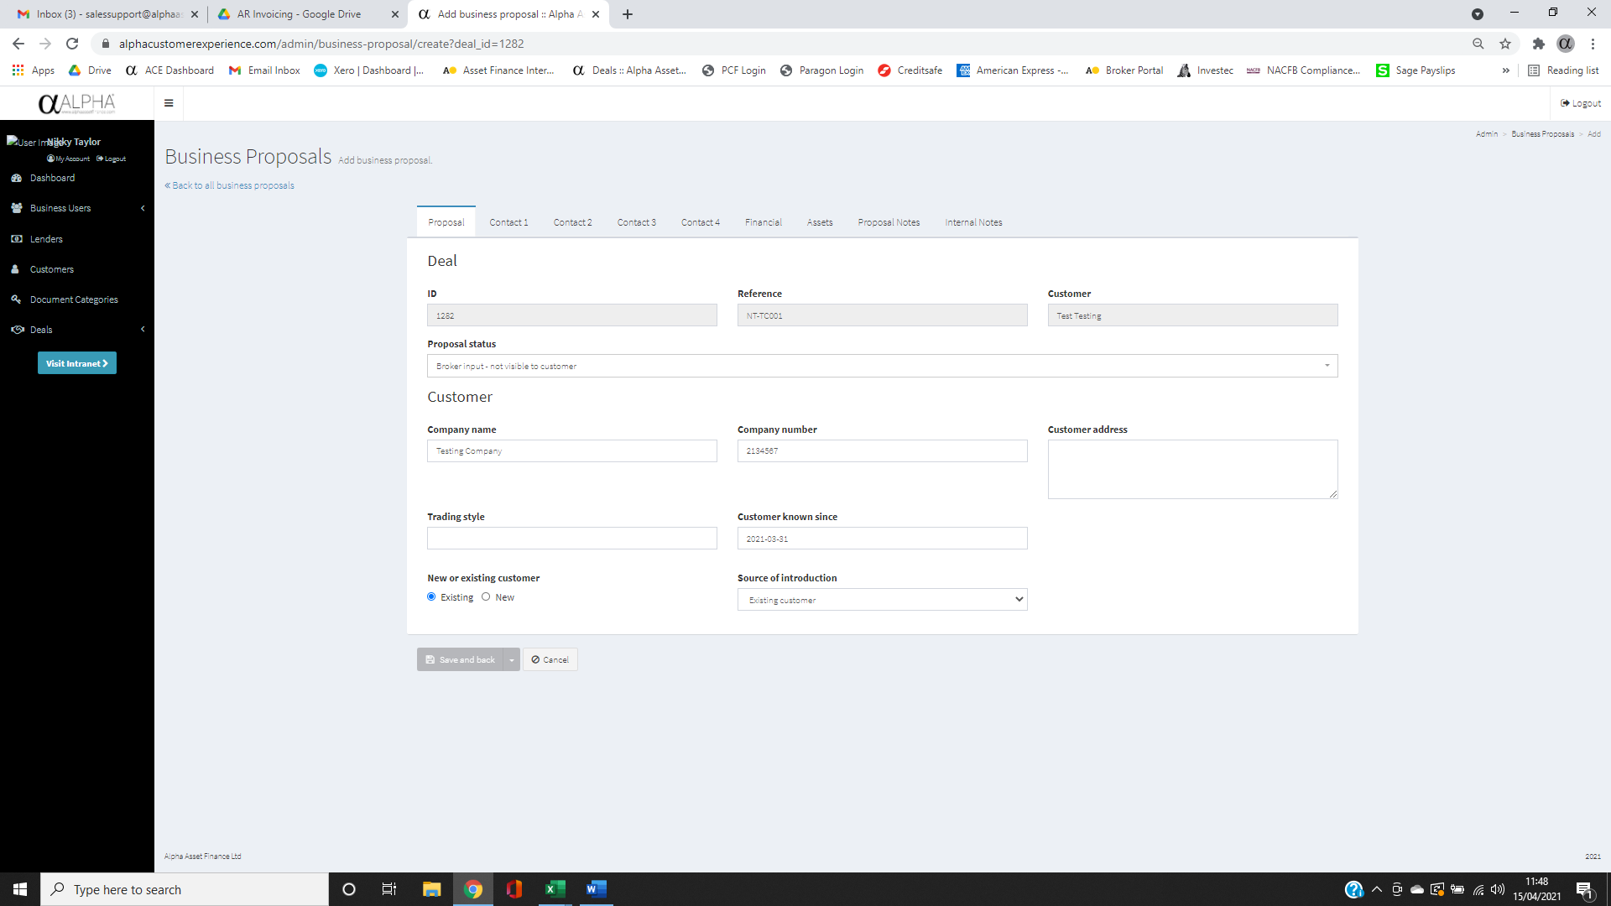



Once you have completed the information you will see the following screen:

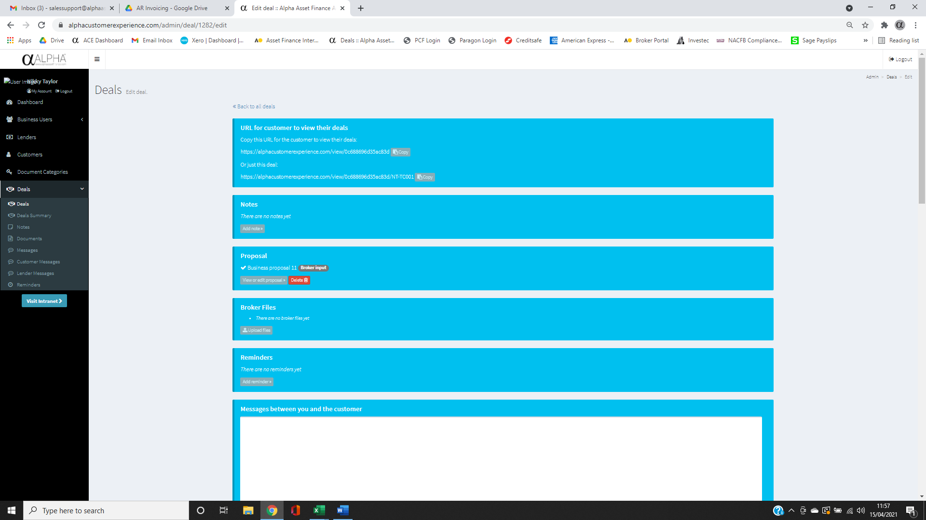



Click view or edit proposal, then click the finalise tab and create a pdf:

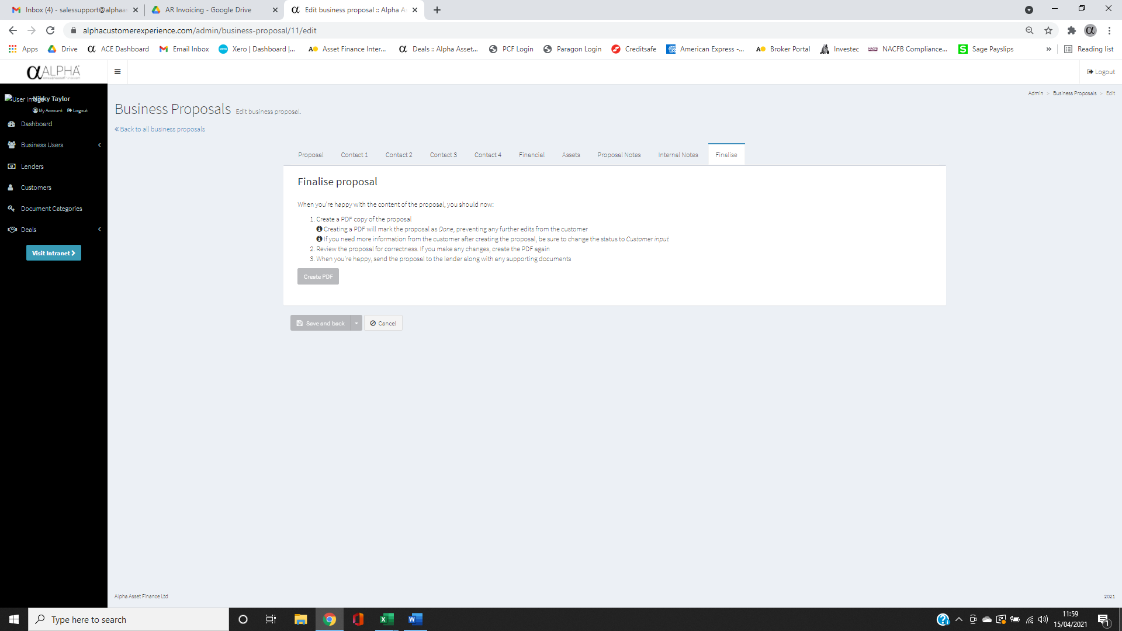



This will create the pdf and you can download and send with the rest of your documents to the lender.

The instructions if you need to amend/add anything are in this screen:

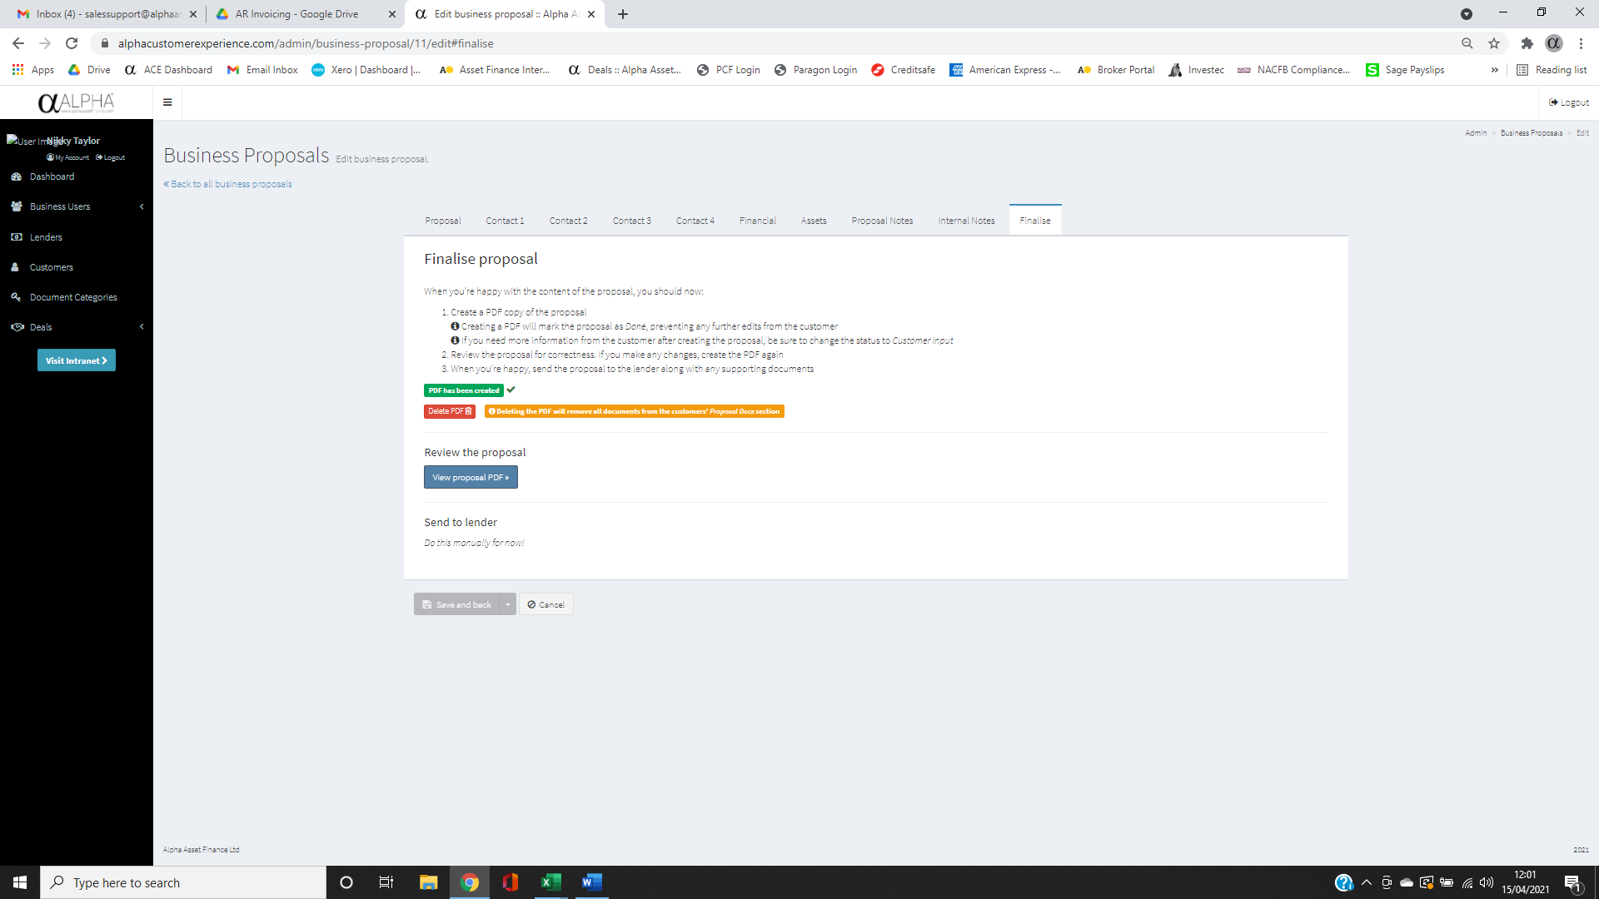

With the personal form you change the proposal status to Customer input click save and back. You then go back into the form and there is a box at the bottom to send the notification to the customer for them to complete. Once they have returned it to you follow the previous steps.

